OnBase HR Guide

Overview
- Source: Print to OnBase for electronic documents:
- Source: Ad Hoc Capture in OnBase for single document in the Unity Client with your desktop scanner
- Source: Use the big copy machines and look for a “Scan to _____Fax” scan queue option destination
- Source: Individual Email Capture
- Use batch processing if needed to split bulk scan documents.
- Index the documents based on the rules. Add any notes needed.
- Use Document Retrieval to open the documents to be sure they were captured correctly.
- Edit captured documents after completion…
  - If any documents are duplicates or should be removed completely, use the right click “Send To” function to forward them to your manager. The manager roles can delete whole documents.
  - To delete pages, reorder or add pages, use the right click “Send To” Document Separation option. Then navigate to Document Separation to edit your document and then re-save.

Individual Document Capture

Source: Use Virtual Print to OnBase
The Virtual Print Driver appears as a standard printer in Windows applications and enables users to electronically print documents directly into OnBase. If employment verification requests are received in the Vision box, please print the request to OnBase. You will also need to print the return form to fill out, unless there is an electronic reply option.
            - Check Vision or virtual fax for documentation to capture.
            - Open the Print function and look for Hyland Software Virtual Print driver
            - Select Print on the document that you want to virtually print into OnBase
            - Select the Hyland Virtual Printer from the list of available printer options
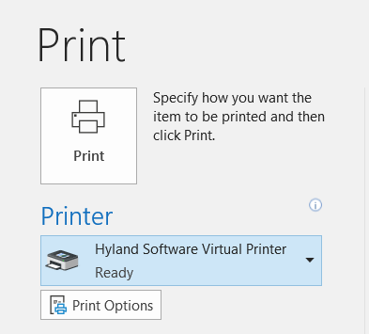
            - Print documents including the cover sheet or email.
            - OnBase’s Import screen will appear with a preview of the document. Index any appropriate keywords onto the document
            - Select Import at the bottom of the keyword section.
-After uploading, a document preview will display by default.

4. Source: Individual Email Capture
When documents arrive in an email account, you can use Outlook Integration to import the email and any associated attachments into OnBase. If employment verification requests are received by email, please use these steps to capture the request. You will also need to print the return form to fill out, unless there is an electronic reply option.
            - Select the email you would like to upload into OnBase, or the email containing attachments you would like to upload into OnBase.
            - From the OnBase ribbon within Outlook, select the Import button
-This will auto-select the email and all attachments for upload into OnBase, and open a new window with the email and an indexing panel. Note: The auto login may take a minute or two at first.
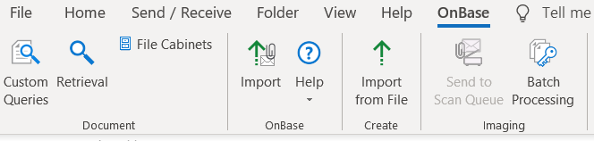
            - To adjust what attachments are selected for upload, use the paper clip at the top of the indexing panel.
-de-select any attachments you don’t want to upload
            - If you don’t want to keep the email itself, use the skip button at the bottom of the indexing panel to skip the import of that item. For most situations, keep the email.
            - The name of the attachment will appear across the top of the indexing panel, so you are aware of which attachment you are indexing.
            - Index each item selected for upload. See steps below.

2. Source: Ad Hoc Capture for Individual Documents
Ad Hoc Scanning allows the user to scan the individual document using a desktop scanner. Use this option to import completed verification forms into OnBase. Please include any supporting documentation in the scan.
      - This method will require that you complete the Index fields at the same time for each document captured.
      - From the Home tab, click the Import button.
      - Select the Acquire button. If the button is grayed out. Reach out to a system administrator for assistance.
      - Select the appropriate Scanning Device from the list of available devices.
      - The scanning interface will appear to complete scanning
      - After scanning, the image will appear in the preview window.
      - If necessary, the rotate options can be used to rotate images to the correct orientation.
      - Select the appropriate Document Type Group from the Document Type Group dropdown to filter the Document Types dropdown accordingly.
      - Select the appropriate Document Type from the Document Type dropdown.
-The file format will default to whatever format the file is stored in
-The document date will default to today’s date
      - Index any related Keywords onto the document.
-Required keywords will appear in red. These must be indexed in order for a document to be uploaded into the system.
      - Select Import at the bottom of the keyword section.
-After uploading, a document preview will display by default.

3. Source: Bulk Scan for Sets of Documents
- Finally, complete/commit all documents to finish the batch
- Use the big copy machines and look for a “Scan to _____Fax” scan queue option destination
  - If you do not see your scan queue in the machine scan destinations, contact Tim Thornton and he will add it.
- After you have scanned all the documents to the Scan Queue go to Batch Processing
- Start batch processing with Document Separation
- Then continue with Indexing

5. Batch Processing in OnBase Unity Client
Once a batch has been imported into OnBase, the documents in the batch need to be indexed. Recall that documents in a batch move together through the various status queues as the entire batch is worked.
The Batch Processing Layout allows users to see batches that are awaiting some sort of processing in various Status Queues. The Batch Processing Layout is accessed by clicking the Batch Processing button from the Home tab.
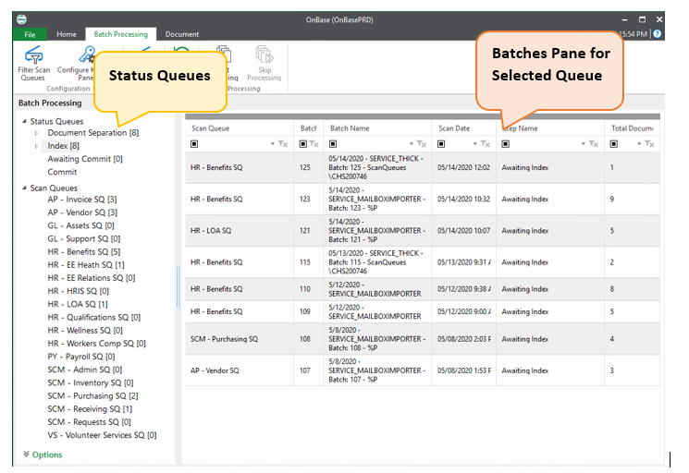

Status Queues
Status queues hold batches of documents that are waiting for some sort of work to be performed. Batches typically start at the top work queue and then transition through the other work queues during processing.
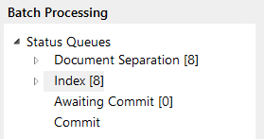

Batch Indexing Layout
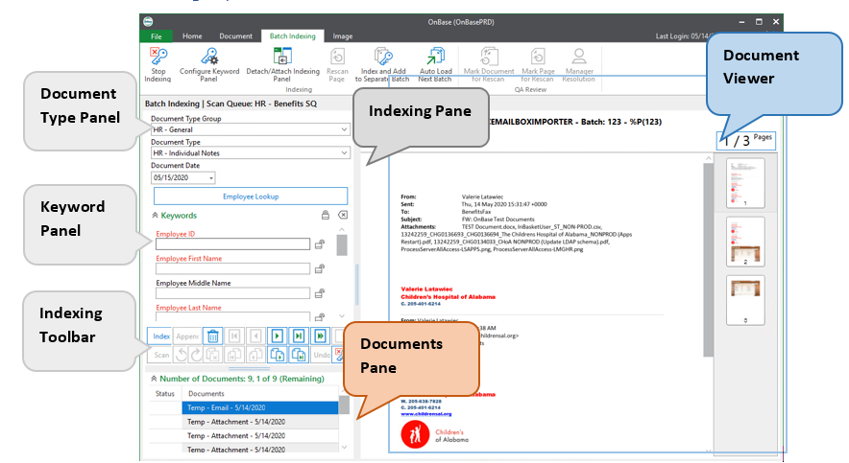
Indexing Pane: Consists of three unique sections for indexing a document.
- Document Type Panel: Contains the Document Type options for the document being indexed.
- Keyword Panel: Contains the Keyword fields for the document being indexed.
- Indexing Toolbar: Contains all of the options necessary to mark documents as indexed and navigate the documents in the batch.

6. Indexing Basics for HR
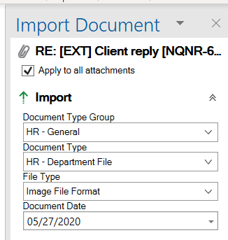
- For all types of Import, you will need to complete the Indexing step, on the right.
- Note that if you have multiple attachments, you can apply one set of index values to them.
- Select the Document Type Group. You will only see the ones you have security to.
- Select the Document Type. It is critical that you select the correct document type. If you are not sure, stop and ask. Once a document is misfiled, it would be very hard for someone to find when needed.
- The system will default the File Type, so you would rarely need to update that field.
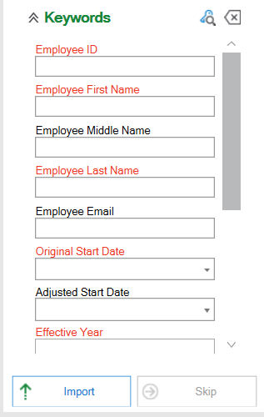
- The Document Date will default to today and should be left as the date the document was captured. There are other fields for event dates.
- For HR documents the next step is to identify which staff person the document is related to, either an employee or affiliate.
- The fields with Red labels are required, but you will not need to type into each field.
- If you know the Infor ID, you can enter just that value. The system will then look up the remaining employee values.

- If you are not sure of the employee ID, you can click the lookup button to search for the person by name.

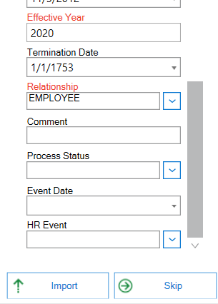
- Once a valid ID number is entered, the system will fill in the rest of the fields up through Relationship.
- You can add a comment that can aid in searching for this document later. Please don’t use this for event date, type or status as we have specific fields for those. This is not required.
- Process status can be used either automatically in workflow or manually for simple non workflow tasks. It is important that we use this consistently. For items that need follow up, please set the status to (Pending).
- Event Date is the date of the event the document is related to, such as hire, term, etc.
- HR Event is the type of event being recorded by the document. The event information will be used to link/audit related documents that are processed at different times.

7. Steps to Retrieve a Stored Document
If you need to look up a completed verification, you may search OnBase using the steps below.
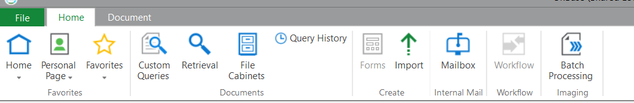
      - From either the Unity Client Home tab
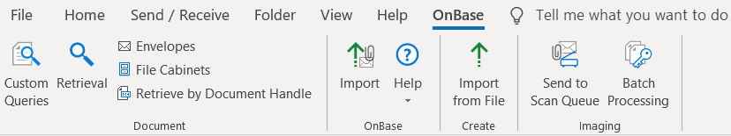
      - or the Outlook OnBase tab,
      - click the Retrieval button.
      - Select a Document Type Group to filter the list of available documents types in the document type dropdown.
      - Select the Document Type(s) you wish to search.
-You can select more than one document type to search across by holding the Ctrl key and selecting multiple document types.
      - Enter a date range and/or keyword information to narrow the results.
-The date range filtering will filter based on the date the document was stored in OnBase.
      - The Document Search Results screen will appear displaying the documents that match the search criteria provided.
      - Select the document you wish to view from this “hit list” by left double clicking the line related to the document you would like to view.
      - The document will open for viewing.
      - Edit the document index properties to set the status of the request.
      - Add a comment or notes if needed.
      - Comments should be used to relate to the processing of the document, such as “waiting on Joni”.
      - Notes should be used to capture additional details or related information about the document.

